AGENT 3 – LINKEDIN OUTBOUND AUTOMATION
Goal
Automatically identify target companies and decision-makers.

Flow:
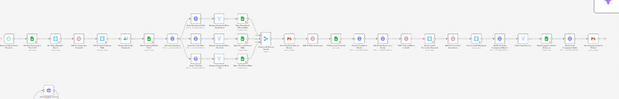
DAILY PROCESS
Runs 6 times per day.

Step 1: Persona Selection
From Excel:
- CTO
- Product Head
- Founder
- Head of Supply

Step 2: Sales Navigator Search
Apply filters:
- Region
- Industry
- Employees
- Revenue
Keywords:
(Full provided list)
Download company data into Excel.

Step 3: Upload to Seamless
Apply filters:
- Department
- Seniority
- Title
Generate 3 Sheets:
- Senior Exec
- Mid-Level
- Technical
Remove:
- Marketing
- HR
- Finance
- Legal
- Support
- Sales

Step 4: Manual Approval Gate
Send filtered sheets to reviewer.
If approved:
Move to Outreach Queue.

Step 5: Outreach Logic
- Send email via Klenty (Sequence 1–6 variants)
- After 12 hours → Send LinkedIn connection
- After accept → Send LinkedIn message

Step 6: Tracking
Pull:
- Email opens
- Clicks
- Replies
- LinkedIn accepts
- Replies
Send engagement list to Shivam.

AGENT 3 KPIs
- Connections sent
- Acceptance rate
- Reply rate
- Meetings booked

